**Decorah  Unitarian  Universalist  Fellowship**

Sunday, July 19, 2020

Gathering virtually since 2020!

**www.decorahuu.org**

Otter Dreaming, Fellowship Coordinator/Musician 387-6050 or otterdreaming@gmail.com

**Welcome and Announcements**

**Today's service** relates to the monthly theme: **Interdependence**

**Chalice Lighting Let us pause for a moment to remind ourselves that even though we are apart, we are together. In spite of virtual space, we are one. Let us bear witness to whom we are becoming. As such, we light this chalice with intention, with optimism, with grace, and with the tenacity that the fierce urgency of now demands of each and every one of us. Masakhane. Let us build together.**

...Dr. Janice Marie Johnson, from the *Service of the Living Tradition* ([**full service**](https://www.uua.org/ga/off-site/2020/slt))

**Opening Words**

**Opening Song** ***We Are*** ...Dr. Ysaÿe Barnwell; [**performed**](https://youtu.be/nTblERFg1vM) by Dr. Barnwell & UU GA 2020 Virtual Choir

**For each child that’s born, a morning star rises and sings to the universe who we are.** (**4x**)

**1 We are our grandmother’s prayers, and we are our grandfather’s dreamings.**

**And we are the breath of our ancestors. We are the spirit of God.**

**2 We are mothers of courage, fathers of time, daughters of dust, and the sons of great visions.**

**We’re sisters of mercy, brothers of love, lovers of life, and the builders of nations.**

**We’re seekers of truth, keepers of faith, makers of peace, and the wisdom of ages.**

***Repeat:***1, 2, 1, 1 (*then continue below*)

**For each child that’s born, a morning star rises and sings to the universe who we are. (2x)**

**We are one.**

**Reading** (Connection to the GA theme: Think about our historical/theological roots)

***Action of Immediate Witness: Address 400 Years of White Supremacist Colonialism***

([**full text**](https://www.uua.org/sites/live-new.uua.org/files/aiw_a_version_2.pdf), including footnotes)

WHEREAS, 2020 marks the 400th anniversary of the first Mayflower voyage, transporting Pilgrims from England to the North American Atlantic Coast;

WHEREAS, the Pilgrims’ invasion of the Wampanoag people led to the enslavement of Indigenous peoples on the East Coast and the removal of and genocide against Indigenous peoples across the continent;

WHEREAS, many Unitarian Universalist congregations uncritically trace their origins to the Pilgrims’ “Free Church” tradition – a mythos that sanctifies white supremacy and depends upon erasure of Indigenous peoples;

WHEREAS, white settler-colonialism is extractive, expansive, and based in violent patriarchy – resulting in a preponderance of Missing and Murdered Indigenous Women and creating unsustainable conditions for all living beings;

WHEREAS, the Plymouth Plantation (a for-profit corporation with stockholders in London) established the corporate pattern of using police to extract resources from Indigenous peoples, a pattern repeated at Standing Rock nation and other Indigenous nations that resist pipeline projects and other extractive industries;

WHEREAS, the Mashpee Wampanoag Tribe, whose ancestors’ lands were invaded by the Pilgrims in 1620, and who have inhabited and stewarded parts of present-day Massachusetts for more than 12,000 years, came under attack from the Trump administration in March of this year and were notified that their reservation lands were being terminated; and

WHEREAS, the administration continues in this and other attacks on Indigenous peoples' lands, sacred sites, and sovereignty – even as a federal district judge has temporarily blocked the taking of the Mashpee Wampanoag’s lands.

THEREFORE, BE IT RESOLVED THAT we, the delegates of the 2020 General Assembly of the Unitarian Universalist Association, call upon the Unitarian Universalist Association and its member congregations to:

Continue to gather in solidarity with the Mashpee Wampanoag Tribe, Standing Rock nation, and all Indigenous peoples struggling to preserve their lands, waters, peoples, sacred sites, and sovereignty;

Continue to push for release of Indigenous Water Protectors from prisons, end public policies that criminalize resistance to extractive colonialism, and adopt a vision of prison abolition;

Work nationally, statewide, and locally on public policy that is decolonizing – such as establishing Indigenous Peoples Day, including Indigenous peoples’ histories in public education curricula, and eliminating racist monuments, flags, and mascots;

Work to stop and reverse ecological harm in genuine collaboration with and taking leadership from communities most consistently and harshly impacted by extractive exploitation of land, water, air, and all beings;

Research, identify, and acknowledge the Indigenous peoples historically and/or currently connected with the land occupied by congregations, and find ways to act in solidarity with or even partner with those Indigenous peoples; and Examine practices relative to Indigenous peoples, particularly the narratives regarding UU origins and US holidays including Thanksgiving.

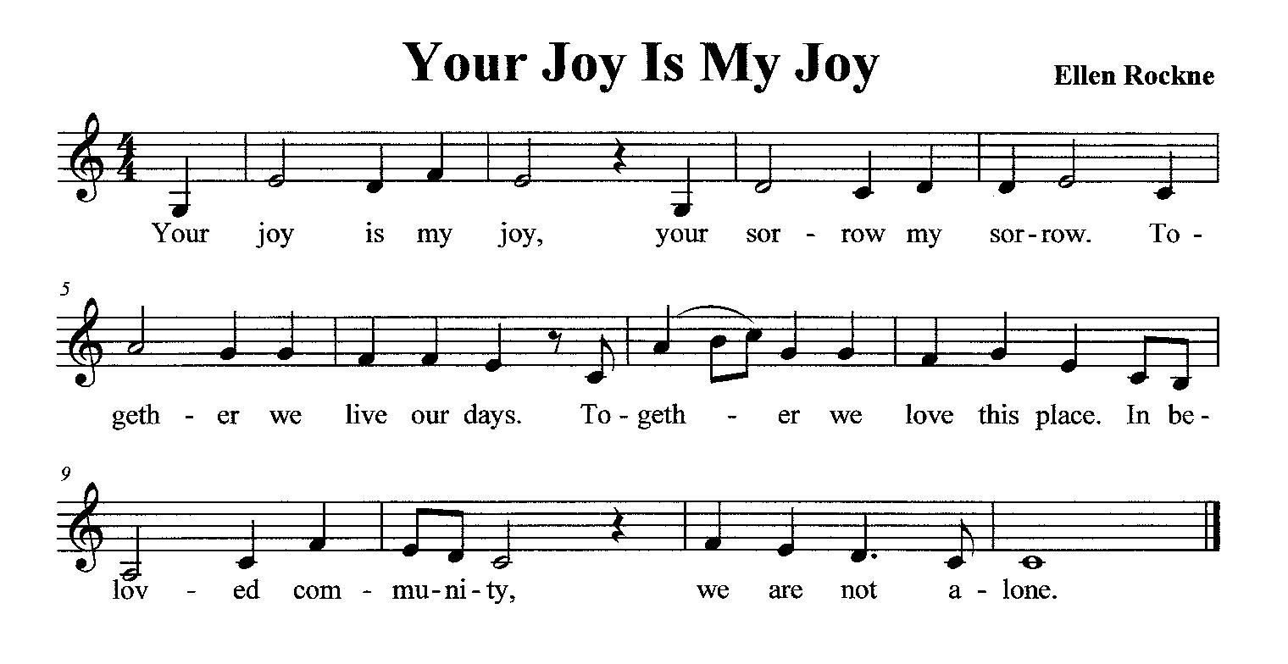**Joys and Sorrows** Please raise your Zoom hand to share any personal joy or concern with the Fellowship.

**Silence Meditation /Response**

**Video Clip** ***President's Report*** ([**full video**](https://www.uua.org/ga/off-site/2020/business/general-session-2/presidents-report))

**Offering /Offertory For all that is our life, we sing our thanks and praise; for all life is a gift that we are called to use to build the common good, and make our own days glad.**  ...Bruce Findlow/Patrick Rickey

**Reading** (Connection to the GA theme: Be inspired)

***Action of Immediate Witness: Amen to Uprising: A Commitment and Call to Action*** ([**full text**](https://www.uua.org/sites/live-new.uua.org/files/aiw_b_version_2.pdf))

BECAUSE Unitarian Universalist congregations covenant to affirm the inherent worth and dignity of every person and promote justice, equity and compassion in human relations, we proclaim loudly, Black Lives Matter!

WHEREAS, police departments and officers across the United States have taken the lives of Black people, including George Floyd, Breonna Taylor, Tony McDade, Nina Pop, Rayshard Brooks and so many others;

WHEREAS, modern policing in the United States is a continuation of what began as slave patrols and have been used to control and harm Black people for generations;

WHEREAS, anti-racist protestors have been met by violence of an increasingly militarized police force;

WHEREAS, many of our faith communities have been complicit in creating the society and systems we currently live within; and

WHEREAS, our ancient and evolving universalist theologies call us to bring an end to all hells that exist and calls for accountability and transformation, not punishment.

THEREFORE, BE IT RESOLVED THAT, as Unitarian Universalists we commit to shaping a world in which love and justice may thrive, where Black leadership, creativity, and resilience is celebrated while Black grief is honored and held with love. We will use our voices to amplify the demands of Black Lives Matter, Black Lives of Unitarian Universalism (BLUU [pronounced Blue]), Diverse and Revolutionary Unitarian Universalist Multicultural Ministries (DRUUMM [pronounced Drum]), Movement for Black Lives (M4BL), Black Youth Project 100 (BYP100), Undocublack, and other organizations by and for Black people.

THEREFORE, we call upon the UUA to collaborate with organizations that have demonstrated a commitment to the work outlined in this AIW, for example, National Bail Out, Reclaim The Block, Black Lives of UU in education, support, and resource development for congregations and to take action through staff commitments via the Organizing Strategy Team, Lifespan Faith Engagement, Congregational Life, and other groups.

THEREFORE, we will create systemic change within our congregations by:

* Revising agreements, and policies to create alternatives to policing (including developing plans for safety and accountability);
* Choosing not to involve police departments, and deactivating security systems that mobilize police response when triggered;
* Engaging in creative transformative justice processes;
* Pursuing abolition of policing systems within the congregations and institutions in which we have power;
* Moving congregational and institutional resources and endowments towards Black liberation organizing and long-term redistribution; and
* Rooting ourselves in theologies of liberation and abolition.

THEREFORE, we will support uprisings with spiritual and material resources, serving as places of respite during protests, funding movements through congregational budgets, and providing spiritual care for protestors and survivors of police and state terror.

THEREFORE, we will advocate in the wider world by:

* Following the example of institutions like the Minneapolis Public School Board in ending contracts with police, and directly intervening alongside communities experiencing policing and ICE raids;
* Joining in widespread calls for immediate defunding of police departments, ending immigration detention, and abolishing ICE; and
* Advocating for reinvestment in communities that have been victimized by policing and other forms of white supremacy.

THEREFORE, we commit to making our congregations and communities authentically multicultural, multiracial, anti-oppressive spaces that dismantle anti-Blackness; resisting a culture of perfectionism, and repairing our mistakes; and given that building the *Beloved Community* in an ongoing and ever evolving process, we commit to staying in this work for the long haul.

**Video Clip** ***The Report of the UUA Commission on Institutional Change*** ([**full video**](https://www.uua.org/ga/off-site/2020/business/general-session-3); [**full text**](https://www.uua.org/uuagovernance/committees/cic/widening);

also for sale by Beacon Press)

**Video Clip** (Connection to the GA theme: We are ready!)

***Synergy Bridging Worship*** ([**full video**](https://www.uua.org/ga/off-site/2020/synergy))

**Closing Song** ***Tomorrow***  ...Kate and Justin Miner; [**performed**](https://youtu.be/anNFR-L_xgk) by UU GA 2020 Virtual Choir

**There will be better days.** (*repeated under other words throughout*)

**Let the wave wash over me.**

**Let the wave wash over me.**

**I am already under.**

**Let the wave wash over me.**

**Extinguishing the Chalice May we continue to be rooted in our revolutionary and living faith tradition, inspired to live our mission in new, innovative ways, and ready to build the Unitarian Universalism that we aspire to be.** ...read by Mr. Barb Greve, co-moderator of the 2020 GA,

during the final general session ([**full general session**](https://www.uua.org/ga/off-site/2020/business/general-session-6))



**Announcements**

**Thank you** to our service leaders this morning,Decorah UU member **Karen Esterl & friends: Carolyn Corbin, Sue Otte, Ellen Macdonald, Matthew Alexander, and Julie Fischer.**  After the service, please treat yourself to a little something, and we’ll be in touch again soon.

**Share-the-Plate** - Our plate recipient for July-August is local organizing around **Black Lives Matter** (e.g., helping purchase a portable public address system). To support the plate recipient, see Decorah UU Giving, below. Or if you prefer to mail a check, please note “Share the Plate” in the memo line, and mail to PO Box 382, Decorah, IA 52101.

**Learn more about General Assembly 2020**

<https://www.uua.org/ga>

<https://www.uuworld.org/articles/general-assembly-2020-summary>

UUA's YouTube Channel: <https://www.youtube.com/c/UnitarianUniversalistAssociationBoston/videos>

**July 26 -** ***No service***, as Decorah UU continues its every-other-Sunday summer schedule.

**Decorah UU Support** - As we continue to find our way through this challenging time, please remember: **if you need help**, let Otter know via phone 563-387-6050 or email otterdreaming@gmail.com. We'll all need support of one kind or another during this time. Please don't hesitate to ask.

**Decorah UU Circles** - We are practicing physical distancing to stay safe in these times, but that doesn’t mean we must be disconnected socially. Check in with folks in your Circle or others as well, and know that together we care for our UU family and friends. Contact Sue Otte if you have questions or comments: sueotte@gmail.com or 563-419-5396.

**Decorah UU Giving** - Decorah UU has set up online payment primarily for donations you might otherwise make in person at fellowship. Go to our [**Decorah UU**](https://www.decorahuu.org/) homepage and click on the "Give Online" button, which will take you to the Giving page. There, you’ll find the “Donate” button which will send your payment through PayPal. You do NOT need a PayPal account. You’ll be asked to choose whether your donation is for **Share-the-Plate** or for **Decorah UU**. You can only choose one, so if you want to donate to both, you will have to repeat the process. You can use a debit or credit card. Below the “Donate” button on the Giving page, you may also consider two options for recurring donations. **Please note:** We deeply appreciate the gracious gifts of our members and friends, whether given on a weekly, monthly, or annual basis. We understand that present circumstances and uncertainty may affect your ability to make a financial commitment to Decorah UU. Know that we value your “gracious gifts” to our fellowship, in whatever form they may be.

**Decorah UU Board of Trustees -** The next meeting of the Board is Tuesday, August 4, 7:00 p.m. via Zoom. Board members for 2020-2021 are Matthew Alexander (chair), Beth Wahlberg (treasurer), Maggie Hayden, Julie Ohde and Lynn Pleggenkuhle.

**Decorah UU Service Archive** - Did you miss a service we conducted by Zoom? Or did you attend but would like to watch it again? You can! Go to [**Decorah UU**](https://www.decorahuu.org/). There are two links to our new YouTube channel: a small YouTube icon in the upper right and a button in the middle that says "Watch past services on YouTube." Once on the YouTube channel page, you can choose the service you want to watch. We will try to post the link within one week of each service. Tip: If you want to see the bulletin or other information about the service, you can click on the SERVICE ARCHIVE button on the homepage. From there you can click on a service and then the “read more” link.

**Decorah UU online** -For more information, please visit our website [**Decorah UU**](https://www.decorahuu.org/) or our **F**[**acebook**](https://www.facebook.com/UUDecorah/?ref=aymt_homepage_panel) page.

**Member Emergency Fund** -Unforeseen troubles come our way from time to time. If you or someone you know in the fellowship could use some help, please let Otter know. We may be able to provide support or short term monetary assistance. Confidentiality will be respected.

**[](https://www.google.com/url?sa=i&url=http://clipart-library.com/filigree-border-cliparts.html&psig=AOvVaw1GSLv8kJiGQ9iwuUHByUXL&ust=1587858990987000&source=images&cd=vfe&ved=0CAIQjRxqFwoTCMC1mIGigukCFQAAAAAdAAAAABAQ)Mail Cheer** - Green Iowa Americorps has made a program for people who feel isolated during the pandemic. To give or receive these friendly letters, call ***Green Iowa Americorp***s at 563-293-5075, or visit the ***Decorah & Winneshiek County Mutual Aid Network***.